**ADVANCED SQUAL::**

**Query1:**

USE AdvancedSQL;

GO

-- Database Schema

CREATE TABLE Customers (

CustomerID INT PRIMARY KEY,

Name VARCHAR(100),

Region VARCHAR(50)

);

CREATE TABLE Products (

ProductID INT PRIMARY KEY,

ProductName VARCHAR(100),

Category VARCHAR(50),

Price DECIMAL(10, 2)

);

CREATE TABLE Orders (

OrderID INT PRIMARY KEY,

CustomerID INT,

OrderDate DATE,

FOREIGN KEY (CustomerID) REFERENCES Customers(CustomerID)

);

CREATE TABLE OrderDetails (

OrderDetailID INT PRIMARY KEY,

OrderID INT,

ProductID INT,

Quantity INT,

FOREIGN KEY (OrderID) REFERENCES Orders(OrderID),

FOREIGN KEY (ProductID) REFERENCES Products(ProductID)

);

-- Sample Data

INSERT INTO Customers (CustomerID, Name, Region) VALUES

(1, 'Alice', 'North'),

(2, 'Bob', 'South'),

(3, 'Charlie', 'East'),

(4, 'David', 'West');

INSERT INTO Products (ProductID, ProductName, Category, Price) VALUES

(1, 'Laptop', 'Electronics', 1200.00),

(2, 'Smartphone', 'Electronics', 800.00),

(3, 'Tablet', 'Electronics', 600.00),

(4, 'Headphones', 'Accessories', 150.00);

INSERT INTO Orders (OrderID, CustomerID, OrderDate) VALUES

(1, 1, '2023-01-15'),

(2, 2, '2023-02-20'),

(3, 3, '2023-03-25'),

(4, 4, '2023-04-30');

INSERT INTO OrderDetails (OrderDetailID, OrderID, ProductID, Quantity) VALUES

(1, 1, 1, 1),

(2, 2, 2, 2),

(3, 3, 3, 1),

(4, 4, 4, 3);

-**- Exercise 1: Creating a Non-Clustered Index**

-- Goal: Create a non-clustered index on the ProductName column in the Products table and compare query execution time before and after index creation.

-- Step 1: Query to fetch product details before index creation

SELECT * FROM Products WHERE ProductName = 'Laptop';

-- Step 2: Create a non-clustered index on ProductName

-- Step 3: Query to fetch product details after index creation

SELECT * FROM Products WHERE ProductName = 'Laptop';

**-- Exercise 2: Creating a Clustered Index**

-- Goal: Create a clustered index on the OrderDate column in the Orders table and compare query execution time before and after index creation.

-- Step 1: Query to fetch orders before index creation

SELECT * FROM Orders WHERE OrderDate = '2023-01-15';

-- Step 2: Create a clustered index on OrderDate

-- Step 3: Query to fetch orders after index creation

SELECT * FROM Orders WHERE OrderDate = '2023-01-15';

-- **Exercise 3: Creating a Composite Index**

-- Goal: Create a composite index on the CustomerID and OrderDate columns in the Orders table and compare query execution time before and after index creation.

-- Step 1: Query to fetch orders before index creation

SELECT * FROM Orders WHERE CustomerID = 1 AND OrderDate = '2023-01-15';

-- Step 2: Create a composite index on CustomerID and OrderDate

-- Step 3: Query to fetch orders after index creation

SELECT * FROM Orders WHERE CustomerID = 1 AND OrderDate = '2023-01-15';

SELECT *

FROM (

SELECT

ProductID,

ProductName,

Category,

Price,

ROW_NUMBER() OVER (PARTITION BY Category ORDER BY Price DESC) AS RowNum

FROM Products

) AS Ranked

WHERE RowNum <= 3;

**Ouput:**

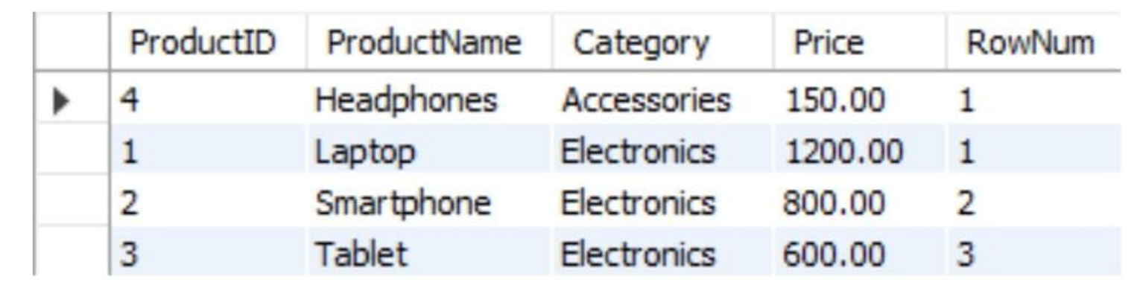

**Query2:**

**-- Use or create your database**

IF NOT EXISTS (SELECT name FROM sys.databases WHERE name = 'AdvancedSQL')

BEGIN

CREATE DATABASE AdvancedSQL;

END;

GO

USE AdvancedSQL;

GO

-- Drop tables if they already exist (to avoid errors on re-run)

IF OBJECT_ID('Employees', 'U') IS NOT NULL DROP TABLE Employees;

IF OBJECT_ID('Departments', 'U') IS NOT NULL DROP TABLE Departments;

GO

-- Create Departments table

CREATE TABLE Departments (

DepartmentID INT PRIMARY KEY,

DepartmentName VARCHAR(100)

);

-- Create Employees table with auto-increment EmployeeID

CREATE TABLE Employees (

EmployeeID INT PRIMARY KEY IDENTITY(1,1),

FirstName VARCHAR(50),

LastName VARCHAR(50),

DepartmentID INT FOREIGN KEY REFERENCES Departments(DepartmentID),

Salary DECIMAL(10,2),

JoinDate DATE

);

-- Insert data into Departments

INSERT INTO Departments (DepartmentID, DepartmentName) VALUES

(1, 'HR'),

(2, 'Finance'),

(3, 'IT'),

(4, 'Marketing');

-- Insert sample employees

INSERT INTO Employees (FirstName, LastName, DepartmentID, Salary, JoinDate) VALUES

('John', 'Doe', 1, 5000.00, '2020-01-15'),

('Jane', 'Smith', 2, 6000.00, '2019-03-22'),

('Michael', 'Johnson', 3, 7000.00, '2018-07-30'),

('Emily', 'Davis', 4, 5500.00, '2021-11-05');

-- Drop procedures if they already exist

IF OBJECT_ID('sp_InsertEmployee', 'P') IS NOT NULL DROP PROCEDURE sp_InsertEmployee;

IF OBJECT_ID('sp_GetEmployeesByDepartment', 'P') IS NOT NULL DROP PROCEDURE sp_GetEmployeesByDepartment;

GO

-- Procedure to insert employee

CREATE PROCEDURE sp_InsertEmployee

@FirstName VARCHAR(50),

@LastName VARCHAR(50),

@DepartmentID INT,

@Salary DECIMAL(10,2),

@JoinDate DATE

AS

BEGIN

INSERT INTO Employees (FirstName, LastName, DepartmentID, Salary, JoinDate)

VALUES (@FirstName, @LastName, @DepartmentID, @Salary, @JoinDate);

END;

GO

-- Procedure to get employees by department

CREATE PROCEDURE sp_GetEmployeesByDepartment

@DeptID INT

AS

BEGIN

SELECT * FROM Employees WHERE DepartmentID = @DeptID;

END;

GO

EXEC sp_InsertEmployee

@FirstName = 'Ravi',

@LastName = 'Kumar',

@DepartmentID = 1,

@Salary = 60000.00,

@JoinDate = '2023-06-25';

GO

-- Execute procedure to view employees in Department 1 (HR)

EXEC sp_GetEmployeesByDepartment @DeptID = 1;

Output:

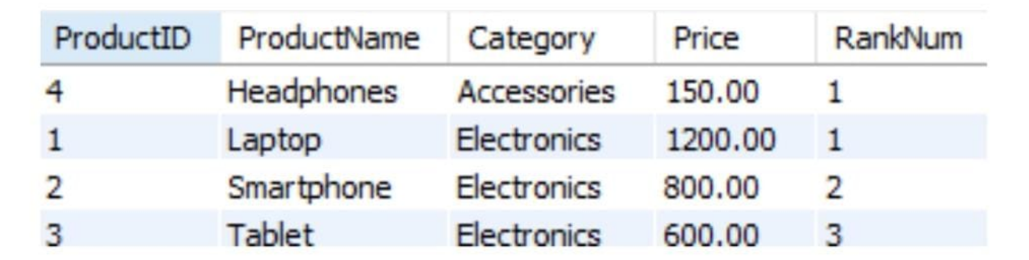

**Query3:**

**USE AdvancedSQL;**

**GO**

**-- Drop tables if already exist (in reverse dependency order)**

**IF OBJECT_ID('Employees', 'U') IS NOT NULL DROP TABLE Employees;**

**IF OBJECT_ID('Departments', 'U') IS NOT NULL DROP TABLE Departments;**

**GO**

**-- Step 1: Create Departments table**

**CREATE TABLE Departments (**

**DepartmentID INT PRIMARY KEY,**

**DepartmentName VARCHAR(100)**

**);**

**GO**

**-- Step 2: Create Employees table with foreign key to Departments**

**CREATE TABLE Employees (**

**EmployeeID INT PRIMARY KEY IDENTITY(1,1),**

**FirstName VARCHAR(50),**

**LastName VARCHAR(50),**

**DepartmentID INT FOREIGN KEY REFERENCES Departments(DepartmentID),**

**Salary DECIMAL(10,2),**

**JoinDate DATE**

**);**

**GO**

**-- Step 3: Insert sample departments**

**INSERT INTO Departments (DepartmentID, DepartmentName) VALUES**

**(1, 'HR'),**

**(2, 'Finance'),**

**(3, 'IT'),**

**(4, 'Marketing');**

**GO**

**-- Step 4: Insert sample employees**

**INSERT INTO Employees (FirstName, LastName, DepartmentID, Salary, JoinDate) VALUES**

**('John', 'Doe', 1, 5000.00, '2020-01-15'),**

**('Ravi', 'Kumar', 1, 60000.00, '2023-06-25'),**

**('Jane', 'Smith', 2, 6000.00, '2019-03-22');**

**GO**

**-- Step 5: Create procedure to count employees in a department**

**IF OBJECT_ID('sp_CountEmployeesByDepartment', 'P') IS NOT NULL**

**DROP PROCEDURE sp_CountEmployeesByDepartment;**

**GO**

**CREATE PROCEDURE sp_CountEmployeesByDepartment**

**@DeptID INT**

**AS**

**BEGIN**

**SELECT COUNT(*) AS TotalEmployees**

**FROM Employees**

**WHERE DepartmentID = @DeptID;**

**END;**

**GO**

**-- Step 6: Run the procedure**

**EXEC sp_CountEmployeesByDepartment @DeptID = 1;**

**Output:**



